Project to blink led on fpga board

Board used

De0 nano by altera intel

Verilog code :

*module blinky(input clk,//50 MHz clock*

*output reg led);*

*reg[31:0] counter;*

*always @(posedge clk)*

*begin*

*if(counter <= 25000000)*

*begin*

*counter <= counter + 1;*

*end*

*else*

*begin*

*counter <= 0;*

*led <= ~led;*

*end*

*end*

*endmodule*

RTL VIEW

*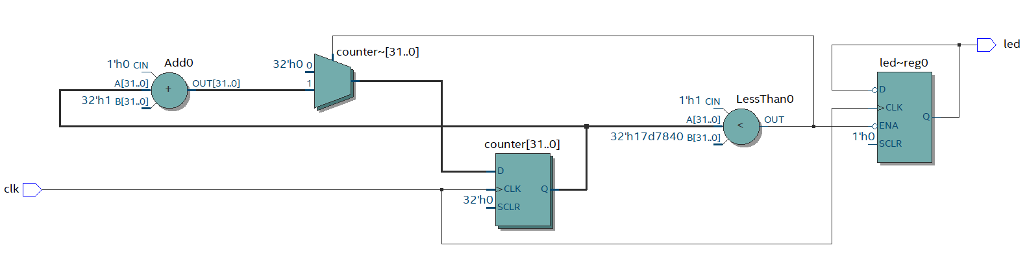*

PIN ASSIGNMENTS



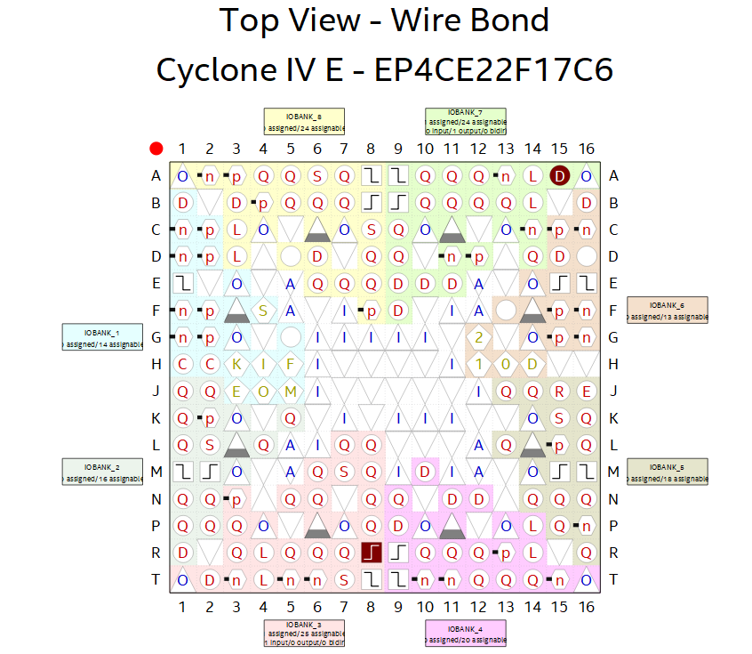

COMPILATION SUMMARY

